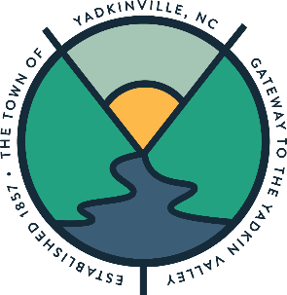
TOWN OF YADKINVILLE
BOARD OF COMMISSIONERS
“SPECIAL MEETING”
BUDGET REVIEW WORKSHOP
FRIDAY, APRIL 25, 2025
12:00 P.M.

AGENDA

1. CALL MEETING TO ORDER – MAYOR NORMAN
2. INVOCATION – MANAGER KOSER
4. 2025-2026 BUDGET WORKSHOP (Attachment #1)

- Review of “DRAFT” Manager’s Recommended Budget for Fiscal Year 2025-2026

4. ADJOURNMENT

